**WITH NOISE AND WITH FILTER FUZZY**

**Image set:**

|  |
| --- |
| **Image 1:-0.1 % Noise** |

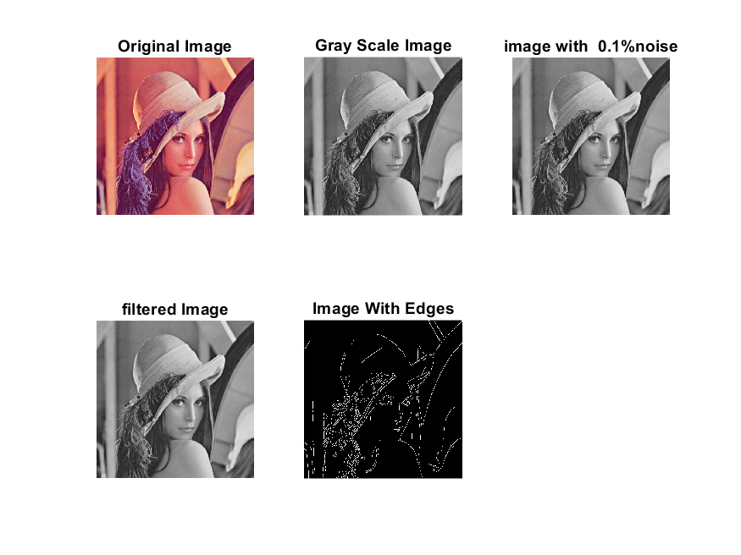

**Image 2:-10 % Noise**

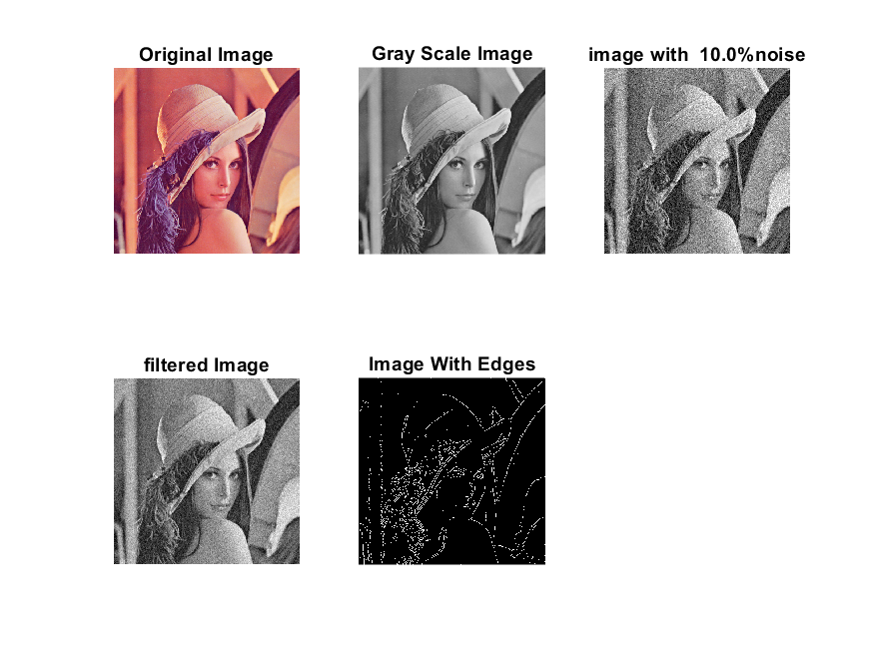

**Image 3:-20 % Noise**

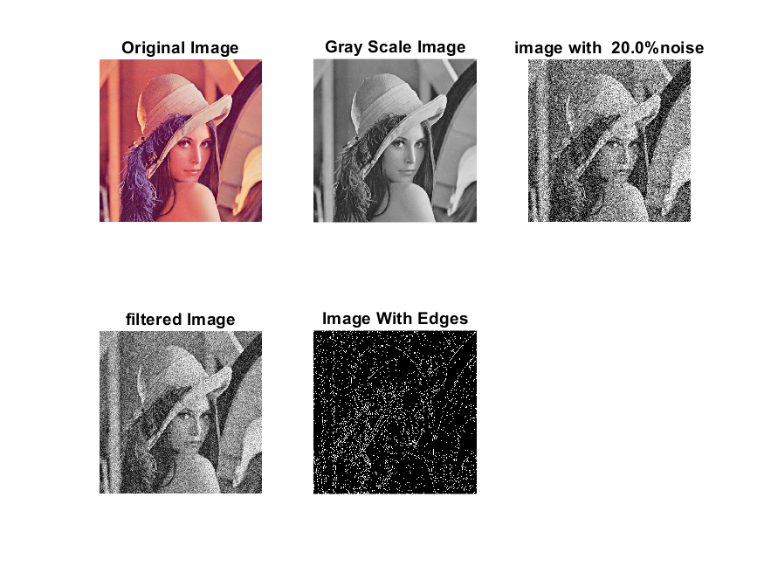

**Image 4:-30 % Noise**

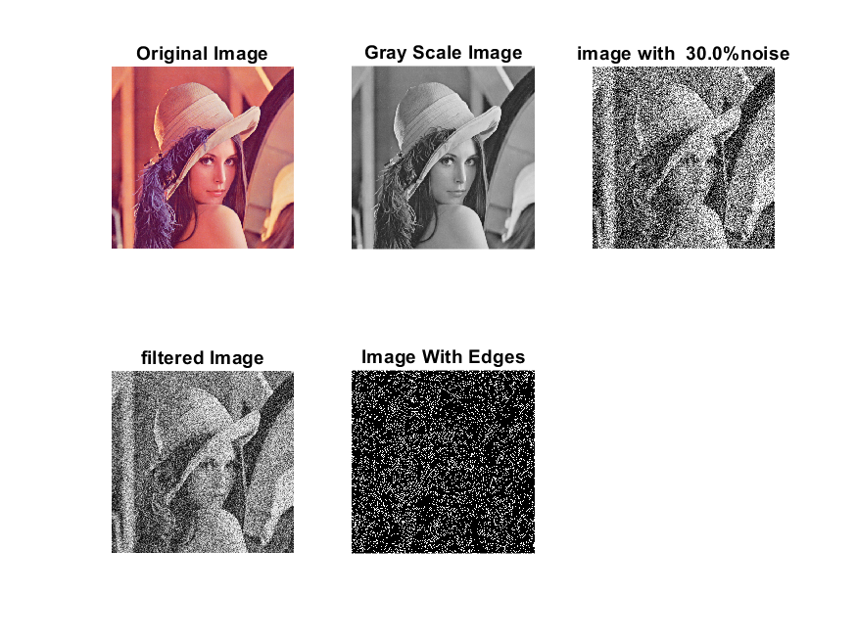

|  |
| --- |
| **Image 5:-40 % Noise** |

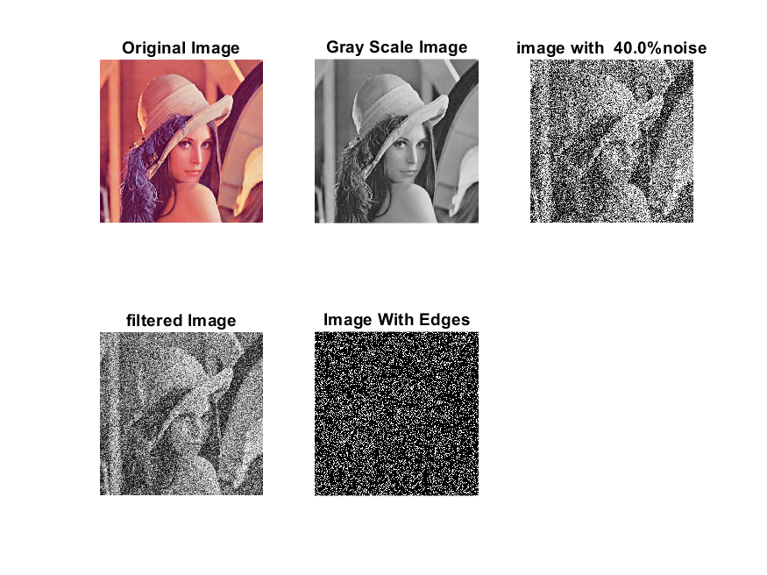

**Image 6:-50 % Noise**

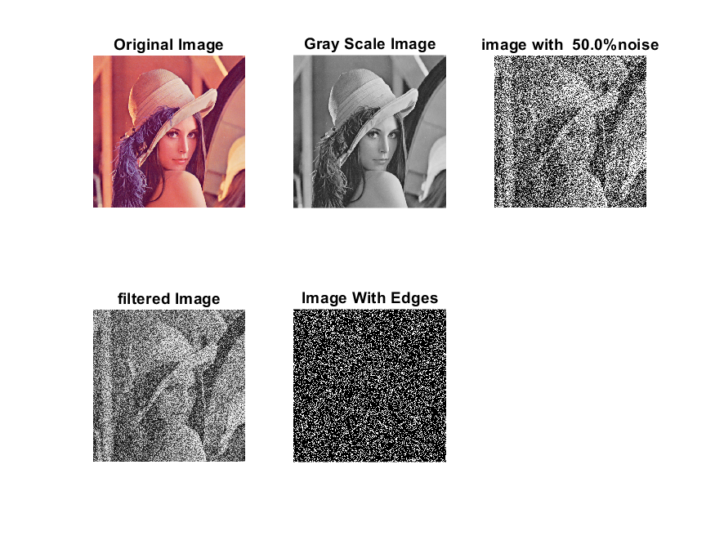

**Image 7:-60 % Noise**

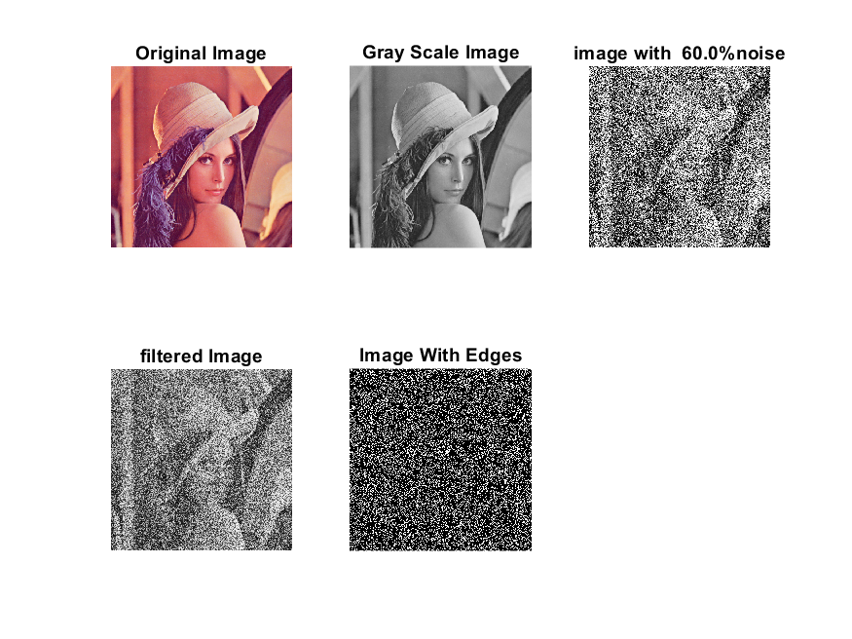

**Image 8:-70 % Noise**

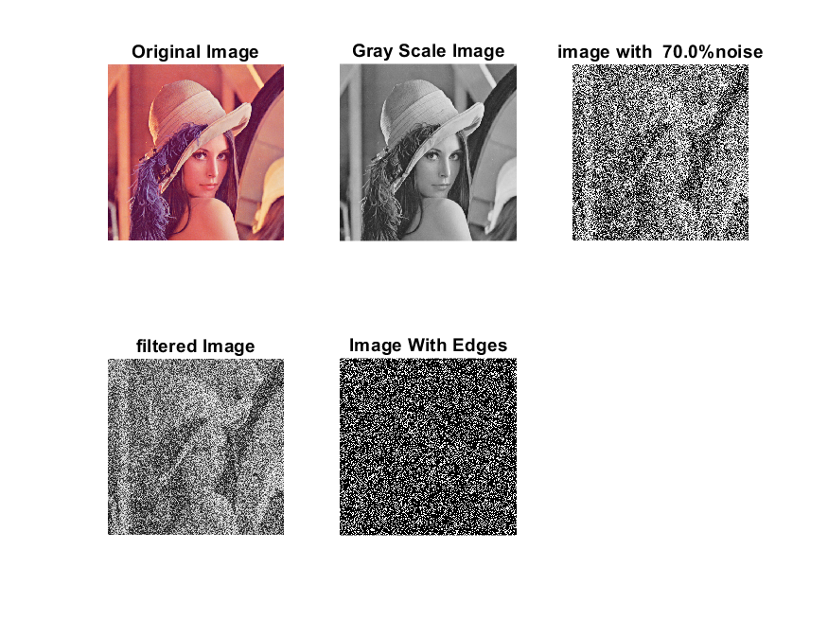

**Image 9:-80 % Noise**

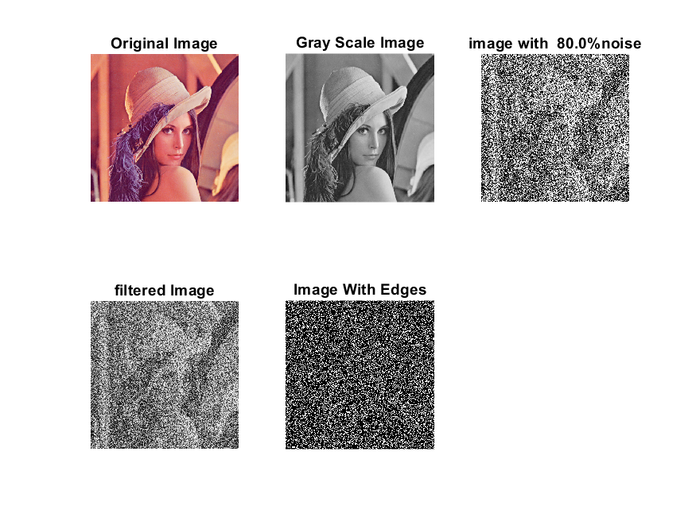

**DATA FILES**

**Image 1:-Noise 0.1**

Original image ideal values:

IM1 image entropy:2.228235e-01

IM1 image mean:0.035828

Ground truth image entropy:0.633825

Ground truth image mean:0.159798

entropy between imt and im1 :0.601612

MSE between imt and im1 :0.169502

Average Difference between imt and im1 :0.123970

Maximum Difference between imt and im1 :1.000000

True Positive values:3424.000000

False Positive values: 5968.000000

True Negative values:214286.000000

False Negative values:38466.000000

Accuracy value: 0.830498

F Measure values:0.133536

Peak Signal-to Noise Ration value: 7.708245

Signal-to Noise Ration value: -6.493523

percentage of pixels that were correctly detected (Pco): 0.081738

The percentage of pixels that were not detected (Pnd):0.918262

the percentage of false alarm: (Pfa):0.142468

Euclidean Distance Value :7.291873

**Image 2:-Noise 10**

Original image ideal values:

IM1 image entropy:2.518690e-01

IM1 image mean:0.042107

Ground truth image entropy:0.633825

Ground truth image mean:0.159798

entropy between imt and im1 :0.596512

MSE between imt and im1 :0.171783

Average Difference between imt and im1 :0.117691

Maximum Difference between imt and im1 :1.000000

True Positive values:3948.000000

False Positive values: 7090.000000

True Negative values:213164.000000

False Negative values:37942.000000

Accuracy value: 0.828217

F Measure values:0.149184

Peak Signal-to Noise Ration value: 7.650187

Signal-to Noise Ration value: -5.792200

percentage of pixels that were correctly detected (Pco): 0.094247

The percentage of pixels that were not detected (Pnd):0.905753

the percentage of false alarm: (Pfa):0.169253

Euclidean Distance Value :8.523700

**Image 3:-Noise 20**

Original image ideal values:

IM1 image entropy:4.296341e-01

IM1 image mean:0.087963

Ground truth image entropy:0.633825

Ground truth image mean:0.159798

entropy between imt and im1 :0.579079

MSE between imt and im1 :0.204243

Average Difference between imt and im1 :0.071835

Maximum Difference between imt and im1 :1.000000

True Positive values:5704.000000

False Positive values: 17355.000000

True Negative values:202899.000000

False Negative values:36186.000000

Accuracy value: 0.795757

F Measure values:0.175646

Peak Signal-to Noise Ration value: 6.898534

Signal-to Noise Ration value: -2.592699

percentage of pixels that were correctly detected (Pco): 0.136166

The percentage of pixels that were not detected (Pnd):0.863834

the percentage of false alarm: (Pfa):0.414299

Euclidean Distance Value :12.682907

**Image 4:-Noise 30**

Original image ideal values:

IM1 image entropy:6.449252e-01

IM1 image mean:0.164482

Ground truth image entropy:0.633825

Ground truth image mean:0.159798

entropy between imt and im1 :0.557221

MSE between imt and im1 :0.264526

Average Difference between imt and im1 :-0.004684

Maximum Difference between imt and im1 :1.000000

True Positive values:7832.000000

False Positive values: 35286.000000

True Negative values:184968.000000

False Negative values:34058.000000

Accuracy value: 0.735474

F Measure values:0.184265

Peak Signal-to Noise Ration value: 5.775310

Signal-to Noise Ration value: 0.125482

percentage of pixels that were correctly detected (Pco): 0.181641

The percentage of pixels that were not detected (Pnd):0.789879

the percentage of false alarm: (Pfa):0.818359

Euclidean Distance Value :17.223307

**Image 5:-Noise 40**

Original image ideal values:

IM1 image entropy:7.467775e-01

IM1 image mean:0.212788

Ground truth image entropy:0.633825

Ground truth image mean:0.159798

entropy between imt and im1 :0.542471

MSE between imt and im1 :0.302212

Average Difference between imt and im1 :-0.052990

Maximum Difference between imt and im1 :1.000000

True Positive values:9224.000000

False Positive values: 46557.000000

True Negative values:173697.000000

False Negative values:32666.000000

Accuracy value: 0.697788

F Measure values:0.188879

Peak Signal-to Noise Ration value: 5.196886

Signal-to Noise Ration value: 1.243759

percentage of pixels that were correctly detected (Pco): 0.165361

The percentage of pixels that were not detected (Pnd):0.585612

the percentage of false alarm: (Pfa):0.834639

Euclidean Distance Value :15.593496

**Image 6:-Noise 50**

Original image ideal values:

IM1 image entropy:8.024923e-01

IM1 image mean:0.244530

Ground truth image entropy:0.633825

Ground truth image mean:0.159798

entropy between imt and im1 :0.530136

MSE between imt and im1 :0.325272

Average Difference between imt and im1 :-0.084732

Maximum Difference between imt and im1 :1.000000

True Positive values:10362.000000

False Positive values: 53740.000000

True Negative values:166514.000000

False Negative values:31528.000000

Accuracy value: 0.674728

F Measure values:0.195524

Peak Signal-to Noise Ration value: 4.877538

Signal-to Noise Ration value: 1.847612

percentage of pixels that were correctly detected (Pco): 0.161649

The percentage of pixels that were not detected (Pnd):0.491841

the percentage of false alarm: (Pfa):0.838351

Euclidean Distance Value :15.220501

**Image 7:-Noise 60**

Original image ideal values:

IM1 image entropy:8.317334e-01

IM1 image mean:0.263332

Ground truth image entropy:0.633825

Ground truth image mean:0.159798

entropy between imt and im1 :0.521455

MSE between imt and im1 :0.338070

Average Difference between imt and im1 :-0.103535

Maximum Difference between imt and im1 :1.000000

True Positive values:11149.000000

False Positive values: 57882.000000

True Negative values:162372.000000

False Negative values:30741.000000

Accuracy value: 0.661930

F Measure values:0.201026

Peak Signal-to Noise Ration value: 4.709935

Signal-to Noise Ration value: 2.169338

percentage of pixels that were correctly detected (Pco): 0.161507

The percentage of pixels that were not detected (Pnd):0.445322

the percentage of false alarm: (Pfa):0.838493

Euclidean Distance Value :15.204885

**Image 8:-Noise 70**

Original image ideal values:

IM1 image entropy:8.474973e-01

IM1 image mean:0.274250

Ground truth image entropy:0.633825

Ground truth image mean:0.159798

entropy between imt and im1 :0.517152

MSE between imt and im1 :0.346043

Average Difference between imt and im1 :-0.114452

Maximum Difference between imt and im1 :1.000000

True Positive values:11535.000000

False Positive values: 60358.000000

True Negative values:159896.000000

False Negative values:30355.000000

Accuracy value: 0.653957

F Measure values:0.202754

Peak Signal-to Noise Ration value: 4.608704

Signal-to Noise Ration value: 2.345762

percentage of pixels that were correctly detected (Pco): 0.160447

The percentage of pixels that were not detected (Pnd):0.422225

the percentage of false alarm: (Pfa):0.839553

Euclidean Distance Value :15.098621

**Image 9:-Noise 80**

Original image ideal values:

IM1 image entropy:8.578034e-01

IM1 image mean:0.281734

Ground truth image entropy:0.633825

Ground truth image mean:0.159798

entropy between imt and im1 :0.513348

MSE between imt and im1 :0.350941

Average Difference between imt and im1 :-0.121937

Maximum Difference between imt and im1 :1.000000

True Positive values:11874.000000

False Positive values: 61981.000000

True Negative values:158273.000000

False Negative values:30016.000000

Accuracy value: 0.649059

F Measure values:0.205175

Peak Signal-to Noise Ration value: 4.547663

Signal-to Noise Ration value: 2.462695

percentage of pixels that were correctly detected (Pco): 0.160774

The percentage of pixels that were not detected (Pnd):0.406418

the percentage of false alarm: (Pfa):0.839226

Euclidean Distance Value :15.130775